**Car rental System:**

**Use case diagram:**

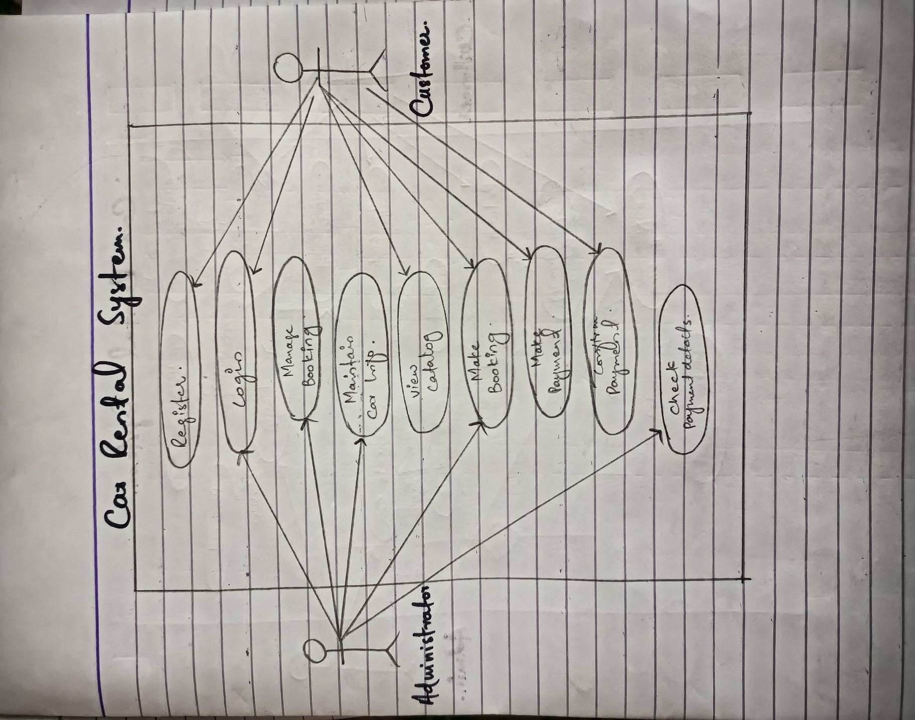

**Fully dressed use case diagram:**

**System sequence diagram:**

**Class Diagram:**

